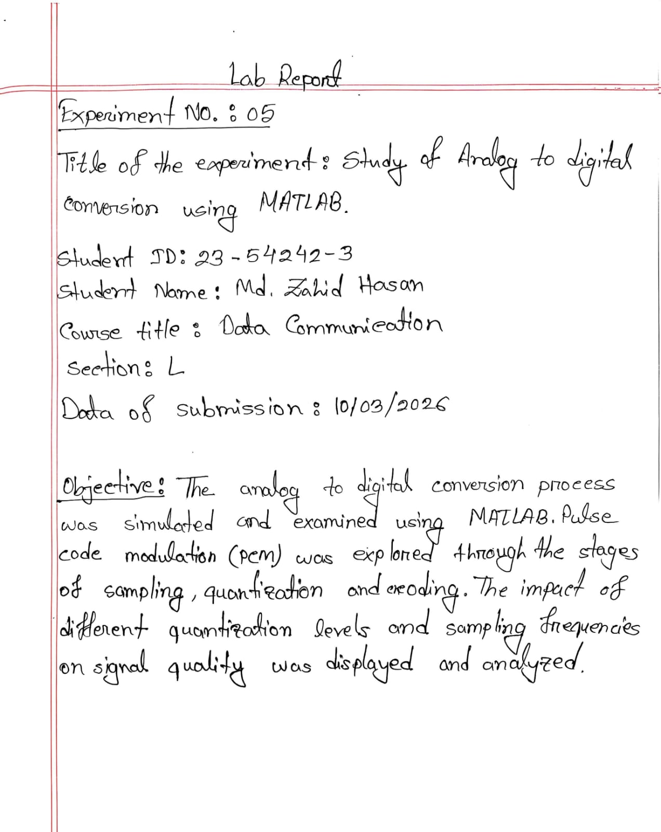

Name: Md. Zahid Hasan, ID: 23-54242-3
clc
clear all
close all

%%%%%%%%%%%%%%%%%%%%%%%%%%%%%%%
% Analog to Digital Conversion
%%%%%%%%%%%%%%%%%%%%%%%%%%%%%%%

time_duration = 0.2;

%% Analog-like signal's representation
% Analog signal generation is not possible in MATLAB
a = [0.4 0.6 0.8]; % amplitude array for composite signal
f = [5 12 20]; % frequency array for composite signal

analog_t = 0:0.0001:time_duration;
analog_sig = a(1)*sin(2*pi*f(1)*analog_t) + a(2)*cos(2*pi*f(2)*analog_t) + a(3)*sin(2*pi*f(3)*analog_t + pi/4);

figure
subplot(1,2,1)
plot(analog_t, analog_sig,'linewidth',1.5)
grid on
xlabel('time in seconds')
ylabel('amplitude in volts')
title('analog signal')

%% Sampling Frequency
fs = 250;
ts = 1/fs;

%% Sampling
samp_t = 0:1/fs:time_duration;
samp_sig = a(1)*sin(2*pi*f(1)*samp_t) + a(2)*cos(2*pi*f(2)*samp_t) + a(3)*sin(2*pi*f(3)*samp_t + pi/4);

subplot(1,2,2)
plot(samp_t, samp_sig,'o','linewidth',1.5)
grid on
xlabel('time in seconds')
ylabel('amplitude in volts')
title(['sampled signal for ',num2str(fs),' Hz sampling frequency'])

%% Levels for Quantization
L = 8;

%% Quantizing
delta = (max(samp_sig) - min(samp_sig))/(L-1); % step size
quant_sig = min(samp_sig) + round((samp_sig-min(samp_sig))/delta)*delta; % quantized signal

figure
subplot(1,2,1)
plot(samp_t, samp_sig,'o','linewidth',1.5)
grid on
xlabel('time in seconds')
ylabel('amplitude in volts')
title('sampled signal')

subplot(1,2,2)
plot(samp_t, quant_sig,'x','linewidth',1.5);
xlabel('time')
ylabel('amplitude')
title('quantized samples')

%% Number of Bits/Sample
nb = log2(L);

%% Encoding
i = round((samp_sig-min(samp_sig))/delta); % index for encoding
dig_data_matrix = de2bi(i,nb); % encoded binary bits are as a matrix here
dig_data = reshape(dig_data_matrix',1,[]); % encoded binary bits are as an array here
disp(['The index values for encoding from quantization of the sampled signal are: ',num2str(i)])
disp(['The converted bits from the input analog signal are: ',num2str(dig_data)])

Name: Md. Zahid Hasan, ID: 23-54242-3
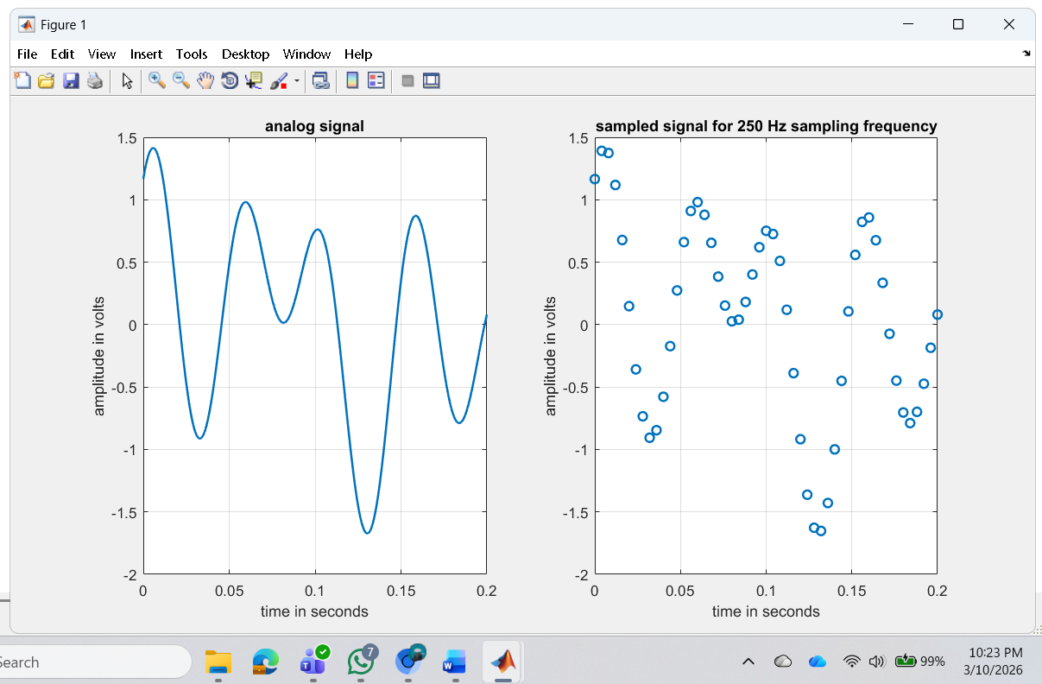
Output Figure 1 for Sampling

Output Figure 2 for Quantizing:
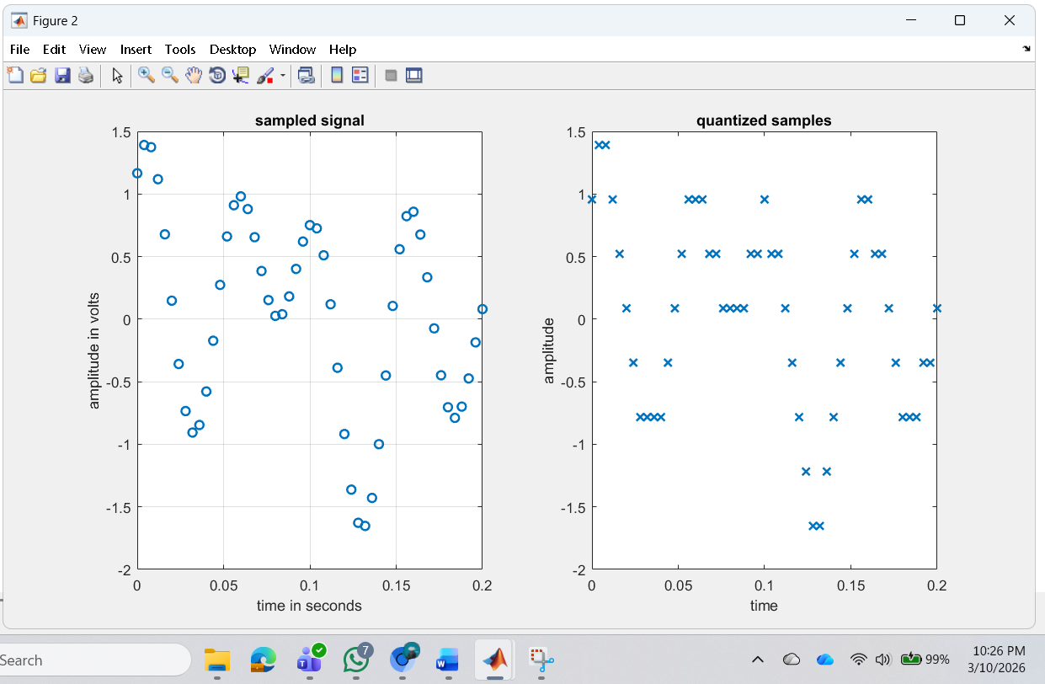
Name: Md. Zahid Hasan, ID: 23-54242-3

Performance Task for Lab Report: (your ID = 23-54242-3)
MATLAB Code:
clc
clear all
close all

% Analog to Digital Conversion

time_duration = 0.2;

%% Values of F and G (change according to your ID)
F = 3;
G = 4;

%% Amplitude and Frequency according to question
a1 = F + 1;
a2 = F + 3;
a3 = F + 2;
a4 = F + 4;

f1 = G + 5;
f2 = G + 7;
f3 = G + 1;
f4 = G + 2;

%% Analog Signal
analog_t = 0:0.0001:time_duration;

sig = a1*sin(2*pi*f1*analog_t) + ...
a2*cos(2*pi*f2*analog_t) + ...
a3*sin(2*pi*f3*analog_t) + ...
a4*sin(2*pi*f4*analog_t);

figure
subplot(1,2,1)
plot(analog_t, sig,'linewidth',1.5)
grid on
xlabel('time (seconds)')
ylabel('amplitude')
title('Analog Signal')

%% Sampling Frequency
fs = 250; % sampling frequency
ts = 1/fs;

%% Sampling
samp_t = 0:ts:time_duration;

samp_sig = a1*sin(2*pi*f1*samp_t) + ...
a2*cos(2*pi*f2*samp_t) + ...
a3*sin(2*pi*f3*samp_t) + ...
a4*sin(2*pi*f4*samp_t);

subplot(1,2,2)
stem(samp_t, samp_sig,'filled')
grid on
xlabel('time (seconds)')
ylabel('amplitude')
title(['Sampled Signal (fs = ',num2str(fs),' Hz)'])

%% Quantization Levels
L = 32; % number of levels

%% Quantization
delta = (max(samp_sig) - min(samp_sig))/(L-1);

quant_sig = min(samp_sig) + round((samp_sig-min(samp_sig))/delta)*delta;

figure
subplot(1,2,1)
stem(samp_t, samp_sig,'filled')
grid on
xlabel('time')
ylabel('amplitude')
title('Sampled Signal')

subplot(1,2,2)
stem(samp_t, quant_sig,'r')
grid on
xlabel('time')
ylabel('amplitude')
title('Quantized Signal')

%% Number of Bits
nb = log2(L);

%% Encoding (Digital Data)
i = round((samp_sig-min(samp_sig))/delta);

dig_data_matrix = de2bi(i,nb);

dig_data = reshape(dig_data_matrix',1,[]);

disp('Index values from quantization:')
disp(i)

disp('Digital bit stream:')
disp(dig_data)

Name: Md. Zahid Hasan, ID: 23-54242-3
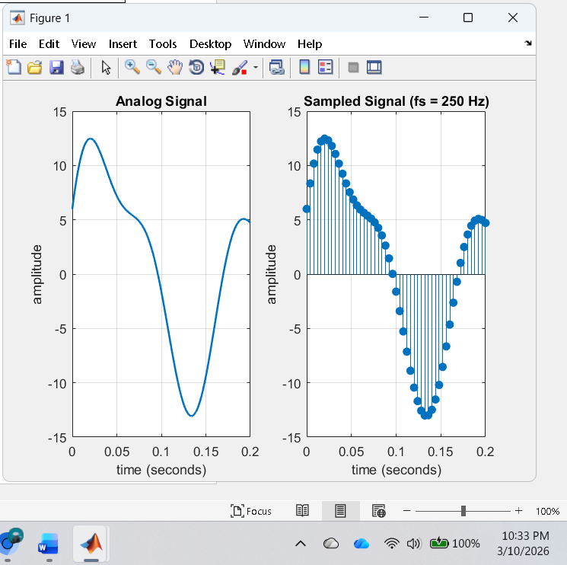
a) Show analog signal, sampled signal, and quantized signal.

Name: Md. Zahid Hasan, ID: 23-54242-3
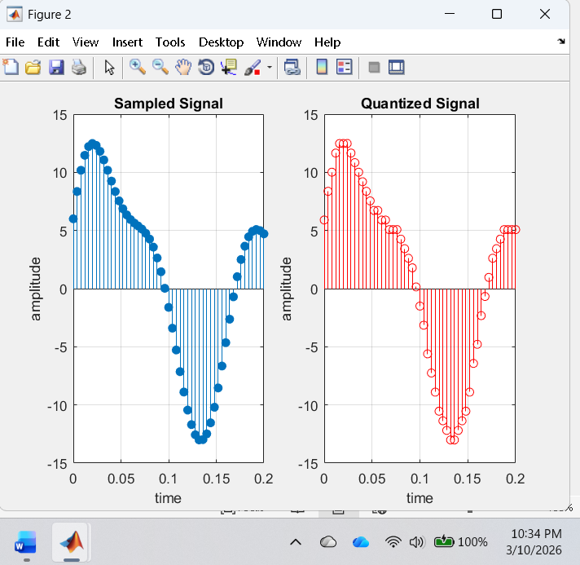
b) Show the digital data from the analog signal.
Index values from quantization:
Columns 1 through 31
23 26 28 30 31 31 31 30 29 28 27 26 25 24 24 23 23 22 22 22 21 20 19 18 16 14 12 9 7 5 3
Columns 32 through 51
2 1 0 0 1 2 3 5 8 10 13 15 17 19 20 21 22 22 22 22
Digital bit stream:
Columns 1 through 31
1 1 1 0 1 0 1 0 1 1 0 0 1 1 1 0 1 1 1 1 1 1 1 1 1 1 1 1 1 1 1
Columns 32 through 62
1 1 1 1 0 1 1 1 1 1 0 1 1 1 0 0 1 1 1 1 1 0 1 1 0 1 0 1 1 1 0

Columns 63 through 93
0 1 1 0 0 0 1 1 0 0 0 1 1 1 1 1 0 1 1 1 1 0 1 0 1 1 0 1 0 1 1

Columns 94 through 124
0 1 0 1 1 0 1 1 0 1 0 1 0 0 1 0 1 1 1 0 0 1 0 1 0 0 1 0 0 0 0

Columns 125 through 155
1 0 1 1 1 0 0 0 1 1 0 1 0 0 1 0 1 1 1 0 0 1 0 1 0 0 1 1 0 0 0

Columns 156 through 186
0 1 0 0 0 1 0 0 0 0 0 0 0 0 0 0 0 0 0 0 1 0 0 0 0 0 1 0 0 0 1

Columns 187 through 217
1 0 0 0 1 0 1 0 0 0 0 0 1 0 0 1 0 1 0 1 0 1 1 0 1 1 1 1 0 1 0

Columns 218 through 248
0 0 1 1 1 0 0 1 0 0 1 0 1 1 0 1 0 1 0 1 1 0 1 0 1 1 0 1 0 1 1

Columns 249 through 255

0 1 0 1 1 0 1
Name: Md. Zahid Hasan, ID: 23-54242-3
c) What are the appropriate values of sampling frequency and number of levels of quantization if minimum required SNR and bandwidth of the channel are 25 dB and 150 Hz respectively.
